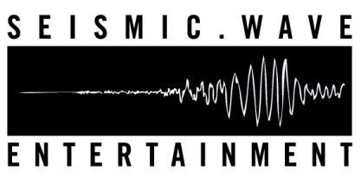
Victory and Associates – Better Luck Next Life: SW012
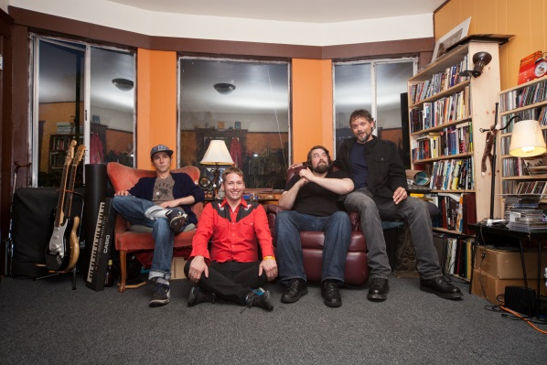
Victory and Associates is a rock band from Oakland, CA. Comprised of vocalist/guitarist Conan Neutron, bassist/vocalist Evan Gritzon, lead guitarist Shane Otis, and drummer Jacob "Mouse" Menough. This is their second full length record, following up 2011's "These Things Are Facts" and last years "Plausibly Wild/Wildly Plausible" double A side single. Victory and Associates formed in early 2010, starting a mission to create true and honest rock and roll trying their best to prove that punk rock is a mindset as much as a strict genre classification, and that big rock does not have to be dumb to be good.

Victory and Associates simultaneously embrace the glorious and the foolish in rock and roll. Where rock 'n' roll not only includes the Rolling Stones, Black Sabbath and Led Zeppelin, but DEVO, the Melvins and the Buzzcocks. There is much more to be said in the idiom of rock 'n' roll and Victory and Associates will darn well say it.

There are no four letter words in any Victory and Associates songs, but there is diversity. The booming "We'll Have to Be Our Own Heroes", blasts out of the gate with a desperate energy and a message of self empowerment. Sorry, the people that were going to save the day decided they had better things to do. The lush Everything's Amazing (Nobody's Happy) is the peppiest song about first world entitlement/taking the marvels of our modern world for granted that you will hear all week. It's also the only song we can think of that's directly inspired by a Louis C.K. comedy bit. The spacey and inexorable groove of For Serious is quite literally a song in defense of sincerity itself, a concept that's been hijacked by utter idiots, fools, wastoids and shameless marketeers.

Better Luck Next Life is a rock record containing ten songs of disillusionment, disappointment, frustration at diminished expectations and hope. Always hope. Even as it seems like hope itself is disappearing on the horizon. Party, right? look - this is not strict cookie cutter genre music and every song doesn’t sound exactly the same, but this IS for real… this is FOR SERIOUS. These are songs directly inspired by the singularity of disappointment, closing one's self off to new experiences, the TV show "Party Down" and the harsh realization that at some point you need to pass the torch to others to carry on. High-minded concepts married to huge riffs, hooks and an undeniable sense of fun. It is dark, battered, exhausted but never defeated

Produced by Toshi Kasai (Melvins, Federation X, Liars, Tool), these ten songs are aimed right at your solar plexus. In the age of hologramatic performers, nostalgia without end, pious indifference and a gruel-like malaise of passively consonant and safe background music. Better Luck Next Life can be hard to pin down, but is ultimately rewarding for those that come along for the ride.

Victory and Associates have shared the stage with the likes of the Thermals, Mike Watt, Helms Alee, the Blind Shake and more. This is their second full-length record and sixth release since starting in early 2010. They intend to make many, many more and continue to bring an immediate, intense and enjoyable live show to the US and beyond.

RIYL: Rocket From the Crypt, Cheap Trick, Mudhoney, the Thermals, Future of the Left, Buzzcocks, Torche, Archers of Loaf.
Victory and Associates – http://www.victoryandassociates.net – victoryandassociates@gmail.com | http://facebook.com/associatesofvictory - @VictoryAndAssoc – 510-535-9404
Seismic Wave Entertainment, PO Box 16157, Oakland, CA 94610
PR: Monica Seide – SpeakEasy PR: monica@speakeasypr.com |
Radio: Team Clermont – Steve Hendricksen: teamclermontsteve@gmail.com

“(Victory and Associates) strike the perfect balance between heaviness and hookiness.” – Rick Florino, ArtistDirect

“Any band claiming Buzzcocks, Cheap Trick, Devo as influences are probably going to be good—and not copyists, given those bands’ idiosyncratic streaks. And Oakland’s V&A do indeed have something going on their second LP. Funny, they don’t sound late ’70s at all; they’re more like a flying, harsh, heavy-riffing ‘90s alt-rock indie band, blowing chucks of righteous noise free of grunge and metal but plenty heavy just the same. It’s a big molten ruckus offset by guitarist/frontman Conan Neutron’s cleaner, precisely sung, classic rock melodies than this sort of din usually confers. They’re gnarly, but like with Grant Hart singing. Punkish music that isn’t easily pigeonholed sometimes struggles for a hearing (since it can’t even rely on conventionalist modern punks). Then again, with a band this roaring, if they get one… (victoryandassociates.net)” Jack Rabid, the Big Takeover

“It’s clear, from production value to actual songwriting, that Victory and Associates are firmly planted in the point in time where the sneer of punk crashed into the force and groove of rock, which wasn’t too long after punk began taking off anyway. Some might say the two are essentially connected at the hip, and it makes more sense once you spend some time with Better Luck Next Life.” Kevin Sellers, Music Emissions

“Victory and Associates do not have to wait for better luck on its next release. It has struck gold on this album. Rock fans should give this record a spin as there is enough variety to satisfy everyone.” -Danielle Boise, Target Audience Magazine

“this sophomore debut from Victory and Associates feels like a darker take on the punk music genre. This darker tone does not bring about a depressing feeling with the music, just an interesting take on a very popular genre. Fans can hear the post-hardcore influence throughout the album but the band seems to be going more towards a rock/pop sound.” –Chelsea Lewis, Celeb Cafe

“While their sophomore album Better Luck Next Life might be filled with tracks with titles like “Are We Having Fun Yet?,” “Ignore Button,” and “Exasperated, Inc,” none of these tracks exude a seething anger like you’d hear from The Sex Pistols or Black Flag. That doesn’t mean that Victory and Associates aren’t intense rockers though. While they definitely have a strong punk ethic running through their tracks, which is most evident on the glorious “The End of Memory,” they often display a humorous, ‘shaking my head’ cynicism rather than an “I am an AntiChrist”-like, and angry, yawp. Much like the grunge made popular by early Nirvana, and Mudhoney in particular, Victory and Associates’ songs thrive on sludgy riffs and uplifting bridges and choruses (both key components of the album’s powerful opening track “We’ll Have To Be Our Own Heroes”). They aren’t afraid to play solos, and they even indulge in the occasional outro drum solo (gasp!). When they put all these elements together, as they do so often on Better Luck Next Life, Victory and Associates demonstrate why they are such a compelling listen. They are a band that isn’t afraid to cross boundaries and embrace their love of just about every kind of rock, often times within the the same song. “For Serious,” one of the album’s standout tracks even dabbles in psychedelica (double gasp!).

Every song on the album would work great in a club setting, but could easily make excellent use of arena acoustics. While Victory and Associates aren’t quite an “arena rock band” just yet, they could easily make the jump. Their songs, as described above, are a melodic blend of what is great about a wide variety of rock music, and have enough space within them to clearly, concisely, and radiantly echo around, while enveloping the crowd of, more spacious venues. If you don’t get to see them live though, Better Luck Next Life, is also one hell of a headphones record. It can take you places like the best of records can. Highly recommended.” – Andy Frisk, Shutter16

